*ALPINE DOMESTIC WATER IMPROVEMENT DISTRICT*

*P.O. Box 595 - 11 County Road 2052 - Alpine, AZ 85920*

*Phone: (928) 339-4631 Fax: (928) 339-4302 Email:* [*shawnadwid@frontier.com*](mailto:shawnadwid@frontier.com)

*Website: alpinewaterandsewer.net ronda@alpinewaterandsewer.net*

# Date November 13, 2024

# Subject: Notice of Unknown Service Line Material

# Dear valued customer,

# We are writing to inform you of an important matter concerning the water service lines in your area. As part of our ongoing efforts to ensure the safety and quality of the drinking water supply, we have recently completed a survey of service lines within our community.

# **Notice of** **unknown service line material**

### **Alpine Domestic Water Improvement District** is focused on protecting the health of every household in our community. This notice contains important information about your drinking water. Please share this information with anyone who drinks and/or cooks using water at this property. In addition to people directly served at this property, this can include people in apartments, nursing homes, schools, businesses, as well as parents served by childcare at this property.

### **Alpine Domestic Water Improvement District** is working to identify service line materials throughout the water system and has determined that the water pipe (called a service line) that **connects from your** **home to the water meter** is made from **unknown material** but may be lead. Because your service line material is unknown, there is the potential that some or all of the service line could be made of lead or galvanized pipe. People living in homes with a lead or galvanized pipe have an increased risk of exposure to lead from their drinking water.

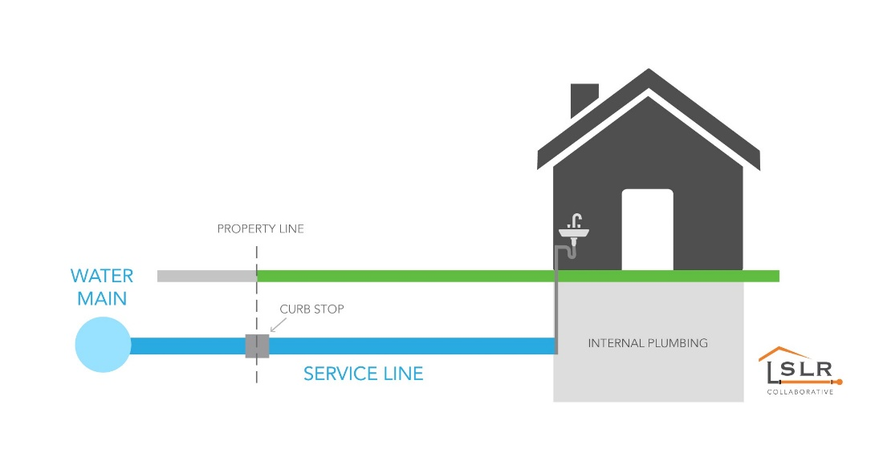

## Identifying service line material

To help determine the material of your service line, please **contact Alpine Domestic Water Improvement District via phone, email and/or visit our website.** EPA has developed an online step-by-step guide to help people identify lead pipes in their homes called Protect Your Tap: A Quick Check for Lead. It is available at: <https://www.epa.gov/ground-water-and-drinking-water/protect-your-tap-quick-check-lead>.

## Health effects of lead

*Exposure to lead in drinking water can cause serious health effects in all age groups. Infants and children can have decreases in IQ and attention span. Lead exposure can lead to new learning and behavior problems or worsen existing learning and behavior problems. The children of women who are exposed to lead before or during pregnancy can have increased risk of these negative health effects. Adults can have increased risks of heart disease, high blood pressure, and kidney, or nervous system problems.*

## Steps you can take to reduce lead in drinking water.

Below are recommended actions that you may take, separately or in combination, if you are concerned about lead in your drinking water. The list also includes where you may find more information and is not intended to be a complete list or to imply that all actions equally reduce lead in drinking water.

**Use filters properly**. Using a filter can reduce lead in drinking water. If you use a filter, it should be certified to remove lead. Read any directions provided with the filter to learn how to properly install, maintain, and use your cartridge and when to replace it. Using the cartridge after it has expired can make it less effective at removing lead. Do not run hot water through the filter. For more information on facts and advice on home water filtration systems, see EPA’s <https://www.epa.gov/water-research/consumer-tool-identifying-point-use-and-pitcher-filters-certified-reduce-lead>.

**Clean your aerator.** Regularly clean your faucet’s screen (also known as an aerator). Sediment, debris, and lead particles can collect in your aerator. If lead particles are caught in the aerator, lead can get into your water.

**Use cold water**. Do not use hot water from the tap for drinking, cooking, or making baby formula as lead dissolves more easily into hot water. Boiling water does not remove lead from water.

**Run your water.** The more time water has been sitting in pipes providing water to your home, the more lead it may contain. Before drinking, flush your home’s pipes by running the tap, taking a shower, doing laundry, or doing a load of dishes. The amount of time to run the water will depend on whether your home has a lead service line or not, as well as the length and diameter of the service line and the amount of plumbing in your home.

**Learn what your service line material is.** Contact us at 928-339-4631 or a licensed plumber to determine if the pipe that connects your home to the water main (called a service line) is made from lead, galvanized, or other materials. [Protect Your Tap: A quick check for lead](https://www.epa.gov/ground-water-and-drinking-water/protect-your-tap-quick-check-lead-0) is EPA’s on-line step by step guide to learn how to find lead pipes in your home.

**Learn about construction in your neighborhood.** Contact us at 928-339-4631 to find out about any construction or maintenance work that could disturb your service line. Construction may cause more lead to be released from a lead service line or galvanized service line if present.

**Have your water tested.** Contact us, your water utility, at 928-339-4631 to learn more about a certified laboratory to have your water tested for lead. Note, a water sample may not adequately capture or represent all sources of lead that may be present**.** For information on sources of lead that include service lines and interior plumbing, please visit <https://www.epa.gov/ground-water-and-drinking-water/basic-information-about-lead-drinking-water#getinto>.

**If you decide to have your water tested, it will not inform you of the type of water pipes you have and will not remove your address from the unknown water pipes list for the EPA.**

## Get your child tested to determine lead levels in their blood.

Although there is no confirmation of having a lead service line, you may wish to speak with a healthcare provider to see if your child’s blood lead level is elevated and/or if there is a need for blood testing, if you are concerned about potential exposure. Please visit <https://www.cdc.gov/nceh/lead/advisory/acclpp/actions-blls.htm> for information on these actions.

**For information about potential financing solutions** to assist property owners with replacement of lead service lines, please contact us at **928-339-4631.**

**For more information on reducing lead exposure** from your drinking water and the health effects of lead, visit EPA’s website at [[*http://www.epa.gov/lead*](http://www.epa.gov/lead)](http://www.epa.gov/lead).